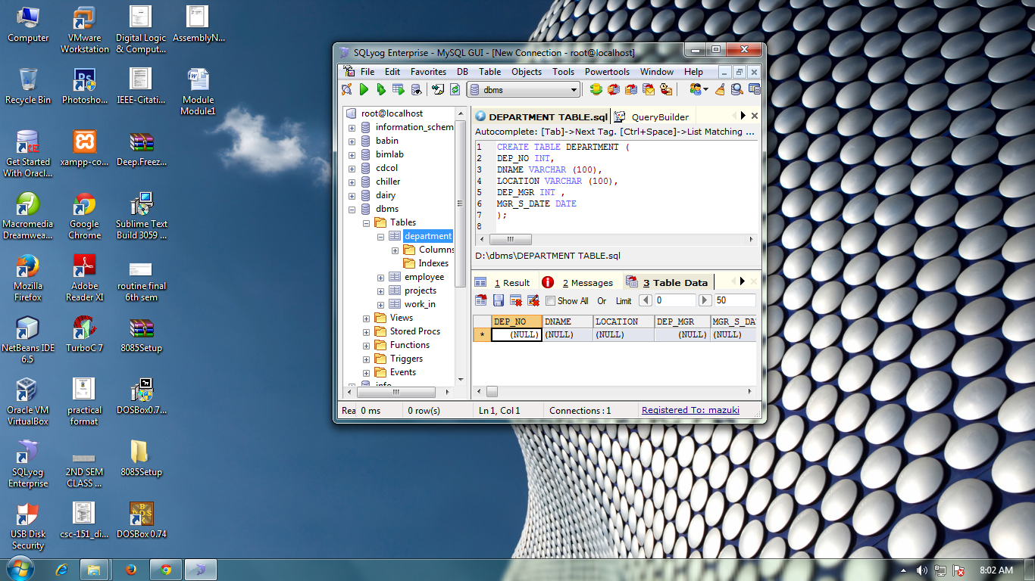

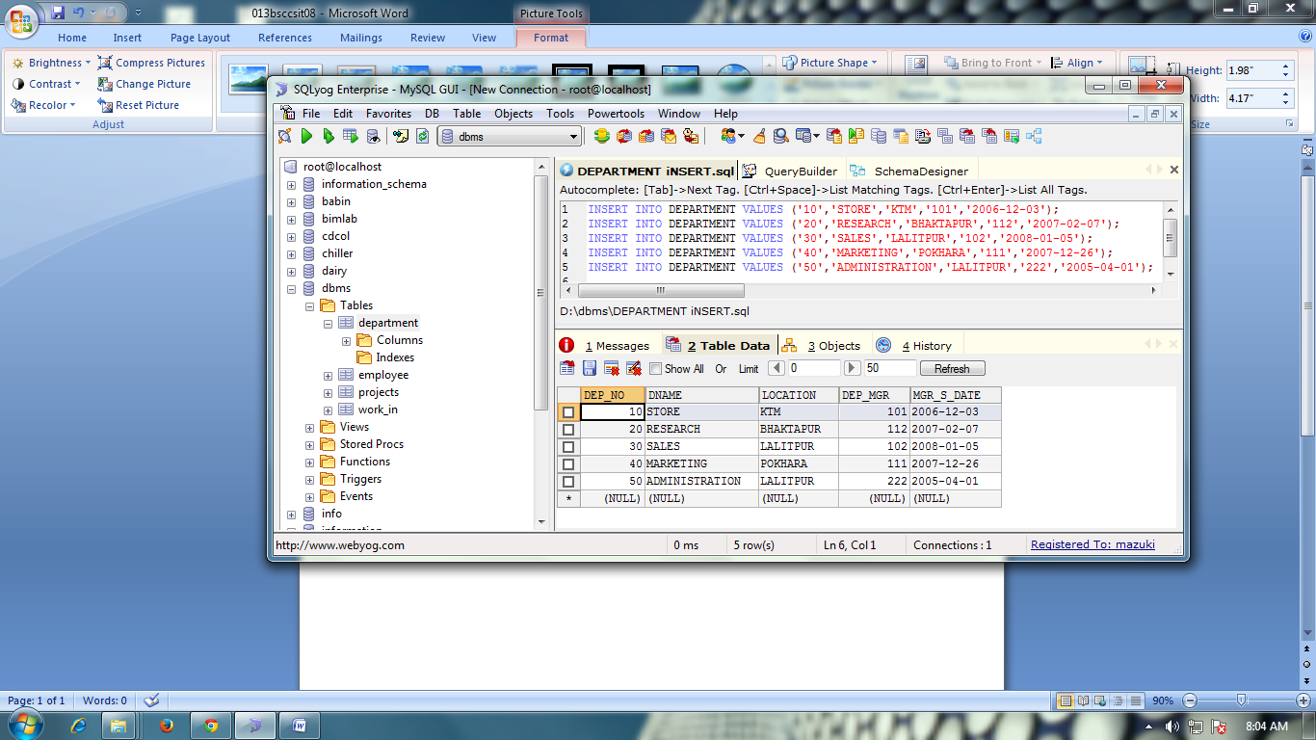



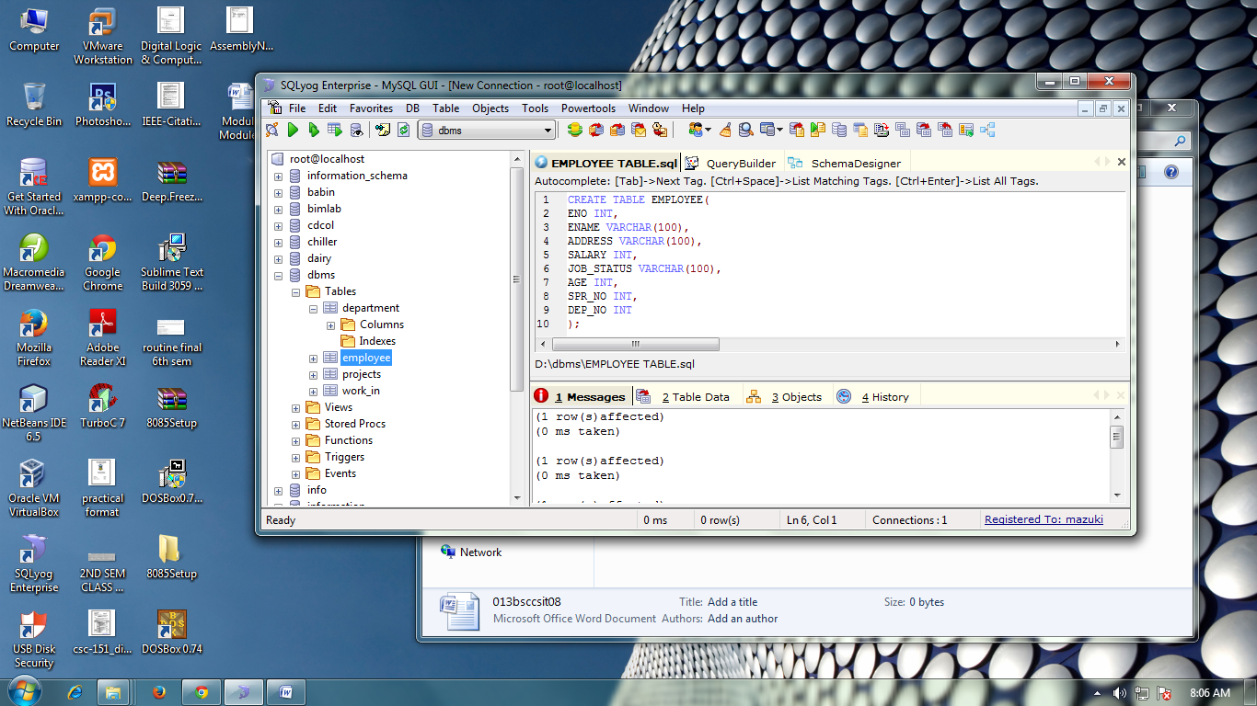

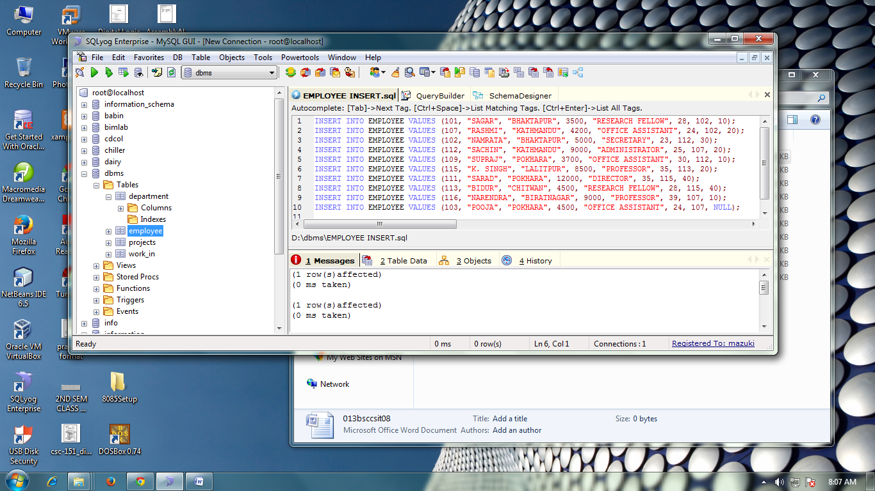

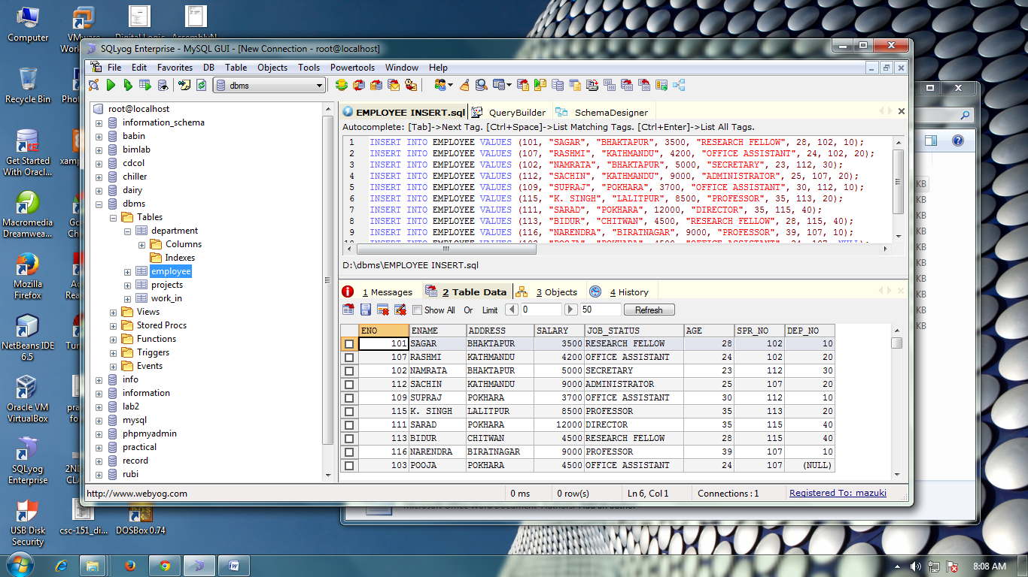

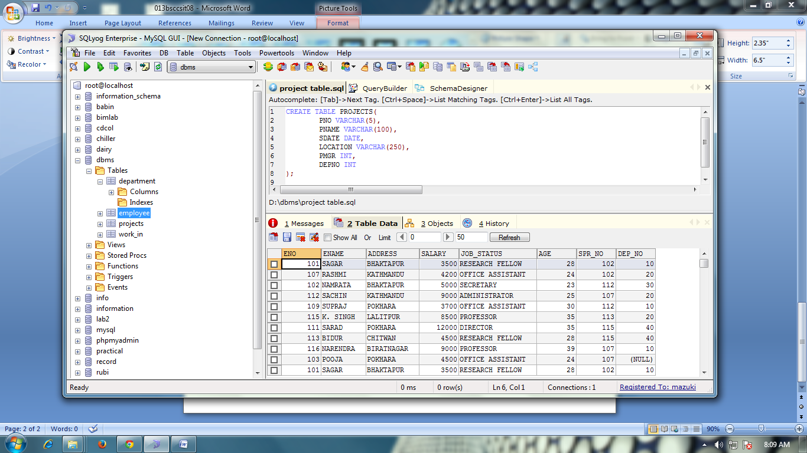

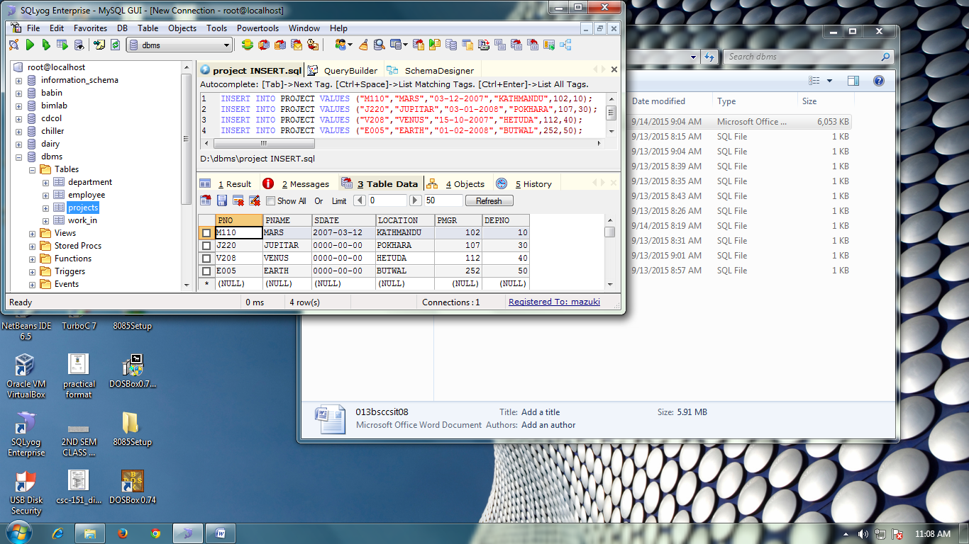



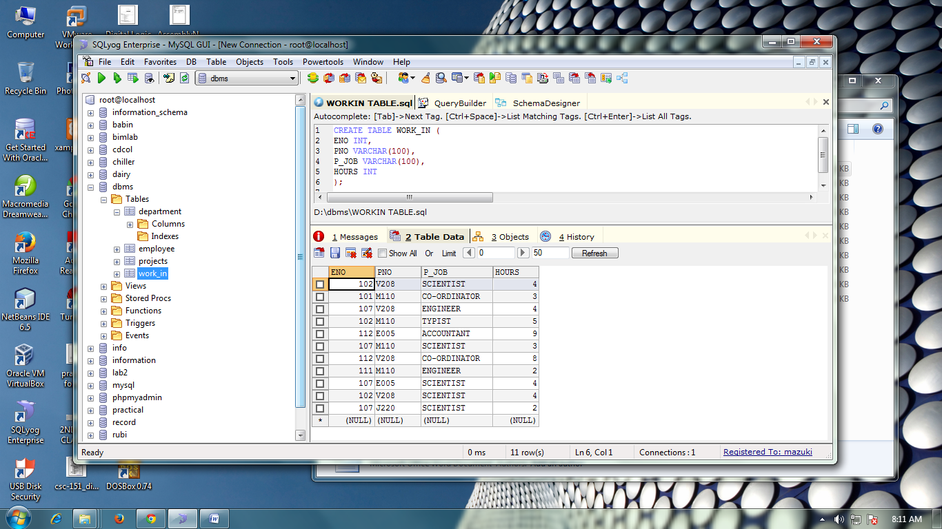

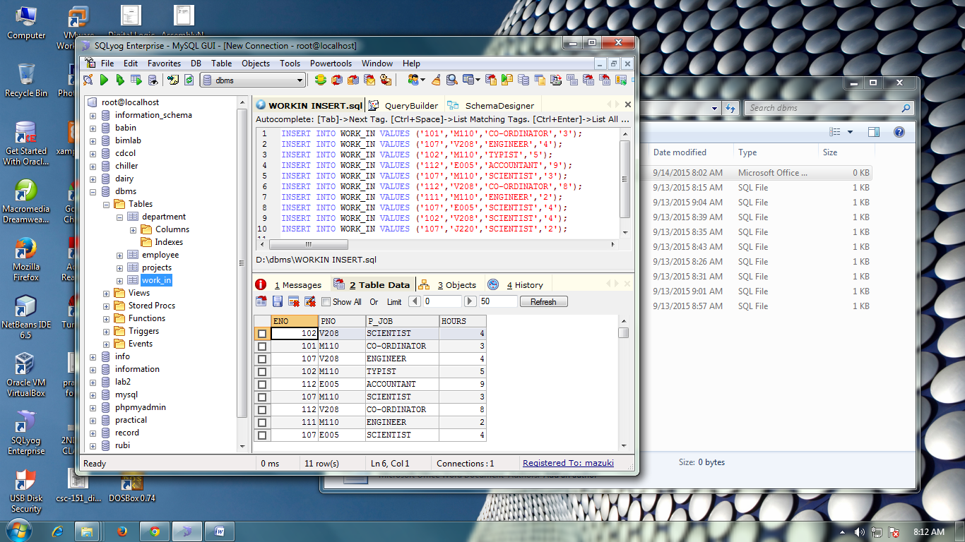

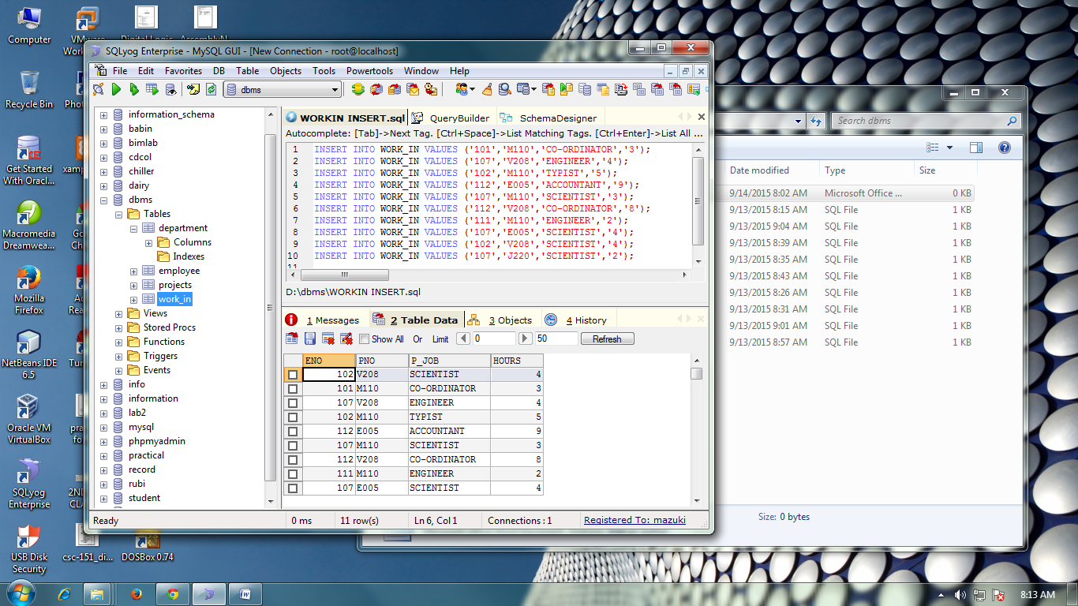

INSERT IN EMPLOYEE

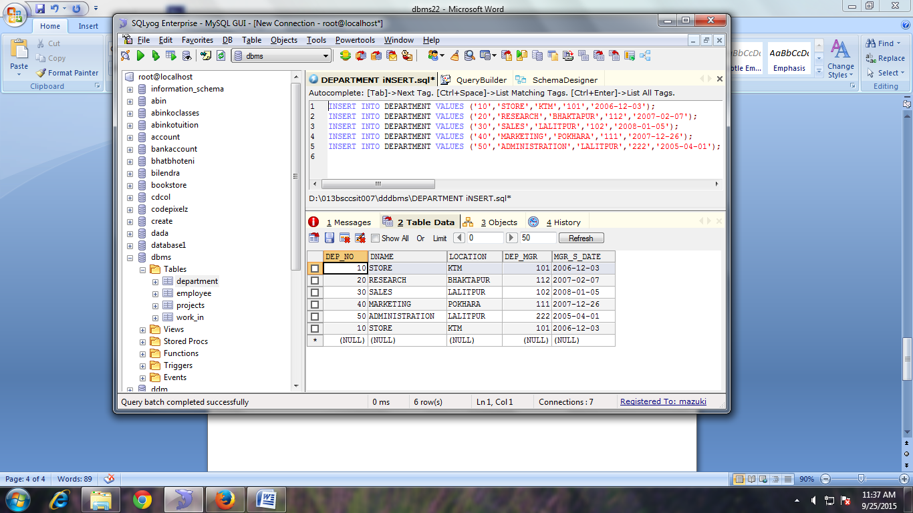

FIND THE ENO, ENAME OF THE EMPLOYEE WHOSE SALARY IS GREATER THAN 4000.

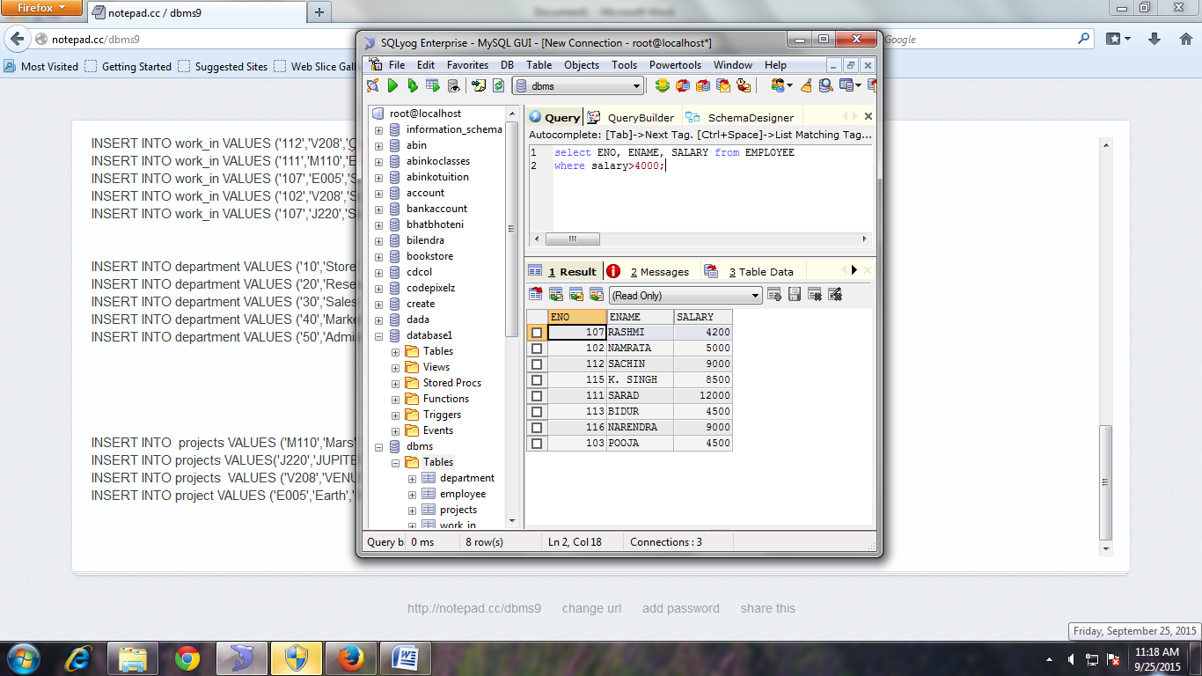

FIND THE ENO, ENAME, SALARY OF THE EMPLOYEES WHOSE SALARY IS GREATER THAN 5000 AND JOB STATUS IS PROFESSOR 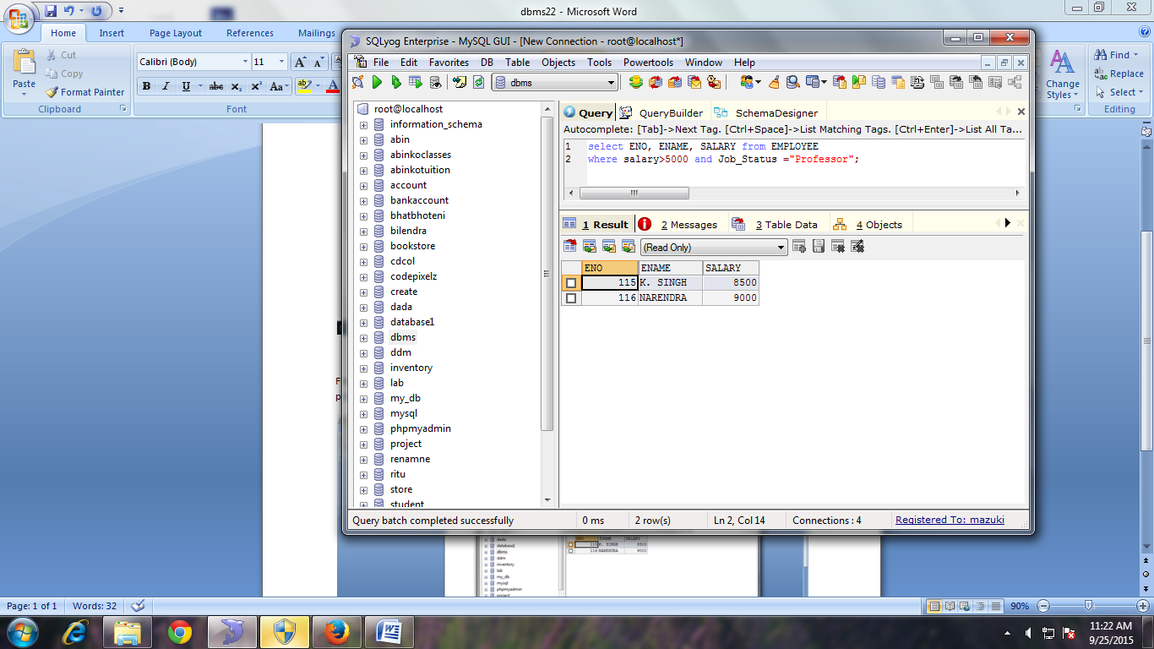

SELECT ADDRESS FROM EMPLOYEE

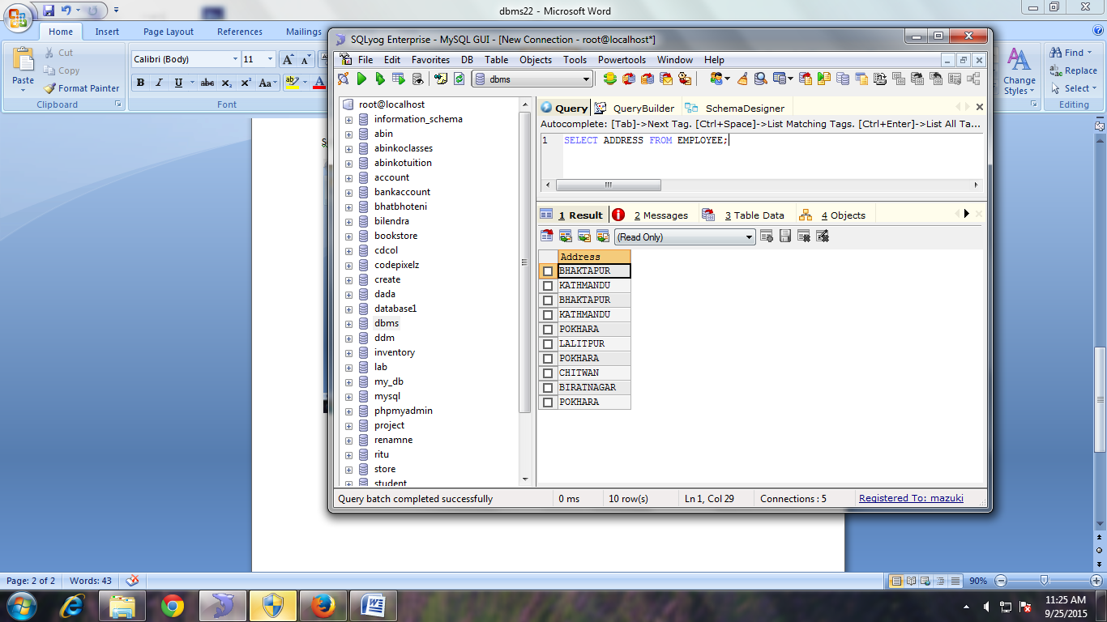

SELECT DISTINCT ADDRESS FORM EMPLOYEE

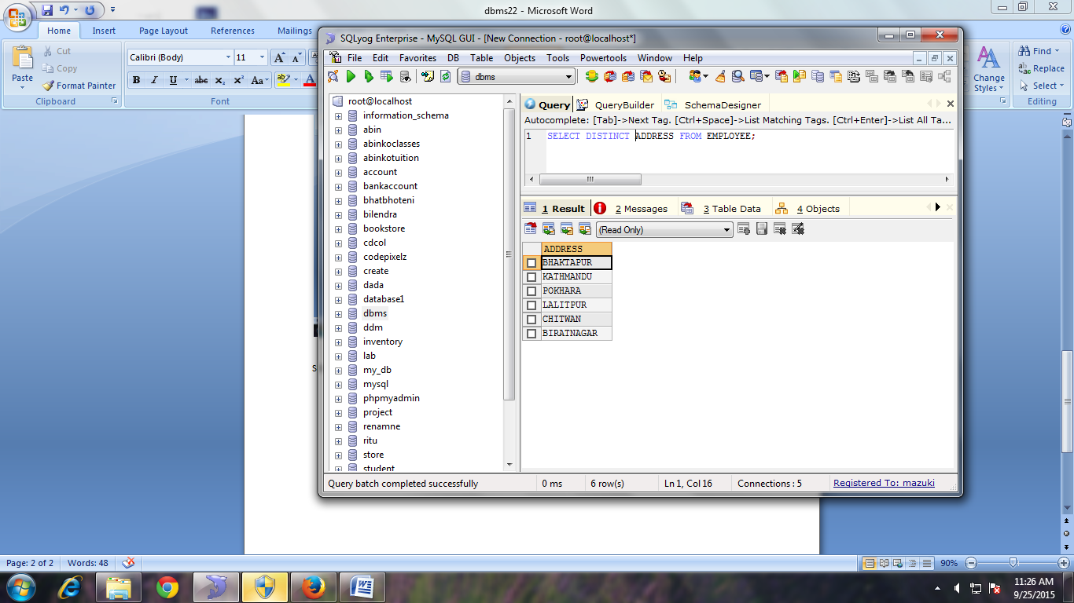

FIND THE ENO, ENAME, SALARY OF THE EMPLOYEE WHOSE DEPARTMENT NO 20 OR JOB_STATUS IS RESEARCH FELLOW.

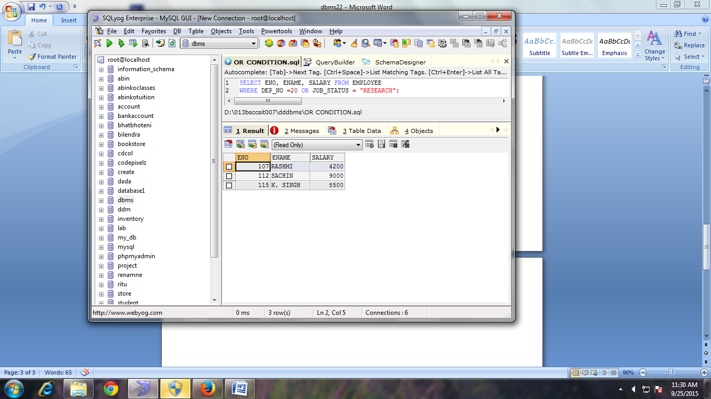

FIND THE ENO, ENAME, AGE, AND SALARY FROM EMPLOYEE WHERE AGE IS BETWEEN 24 AND 28.

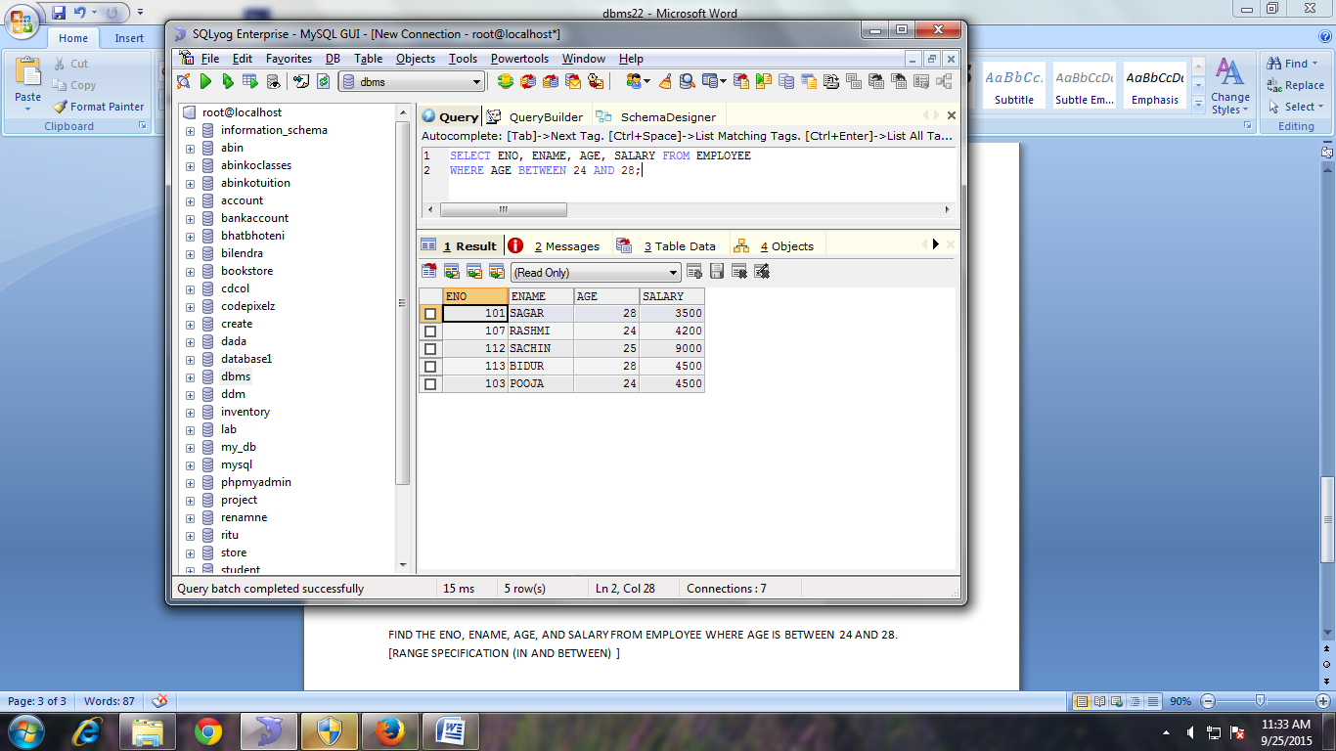

STRING OPERATION

ABC% :

All strings that start with ABC.

Example ;ABCD and ABCDABCD would both satisft the condition.

%XYZ:

All string that end with XYZ.

Example: WXYZ and ZZXYZ would both satisfy the condition.

%AN%

All string that contain the pattern **AN** anywhere.

Example: LOS ANGLES and SAN FRANSCISCO.

FIND ENO, ENAME WHOSE STARTING LETTER ‘SA’.

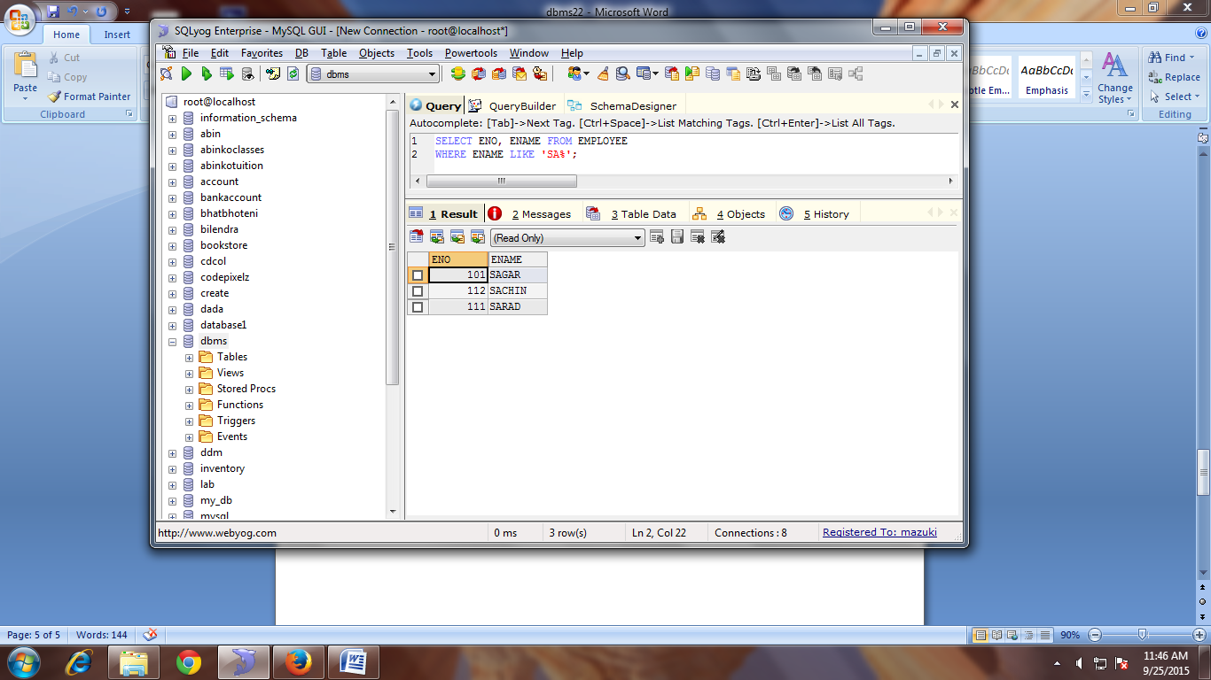

LIST ALL EMPLOYEES’ NAME WITH THEIR PROJECT NAME

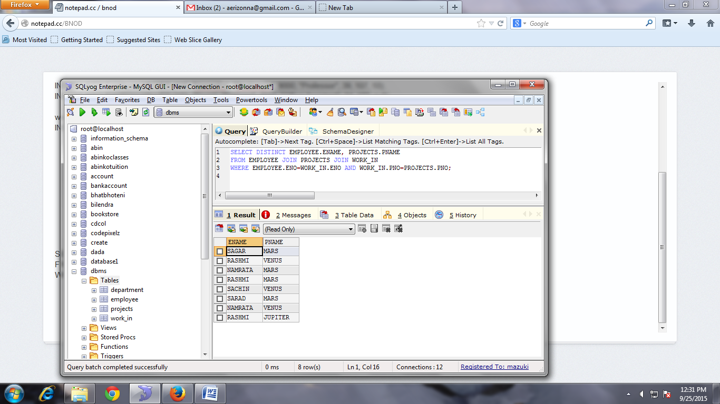

LIST NAME OF ALL EMPLOYEES AND THEIR SALARY WHO ARE WORKING IN PROJECT MARS OR VENUS

LIST NAME OF ALL EMPLOYEE AND SALARY WHO ARE WORKING IN PROJECT EARTH AND VENUS

LIST NAME AND ADDRESS OF ALL EMPLOYEES WHO WORKS IN DEPARTMENT WHICH IS LOCATED IN POKHARA.